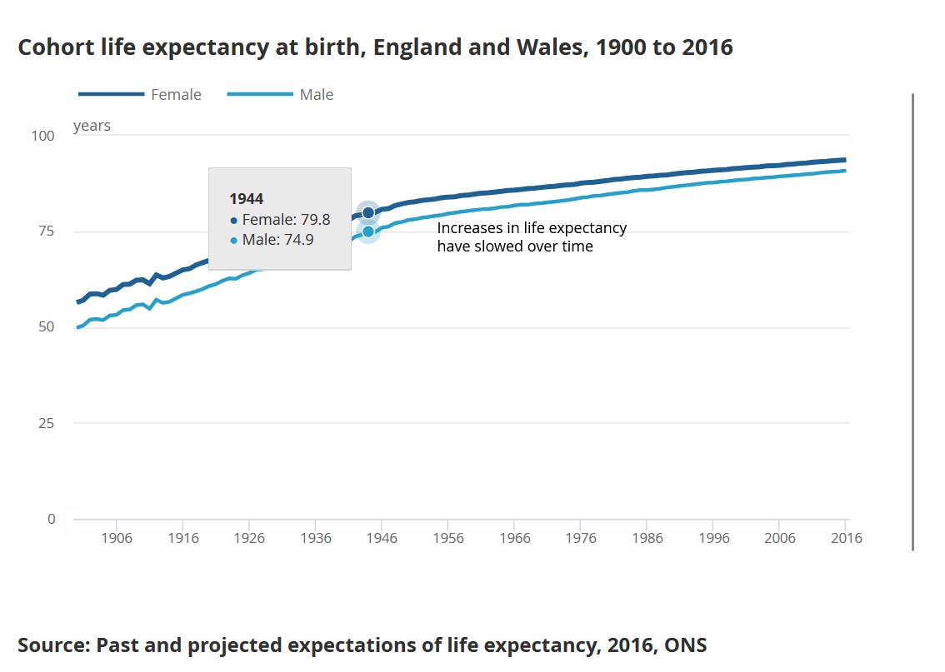

Link: https://www.ons.gov.uk/peoplepopulationandcommunity/healthandsocialcare/healthandlifeexpectancies/articles/whatismylifeexpectancyandhowmightitchange/2017-12-01

The visual offers valuable insights into historical life expectancy trends, emphasizing the importance of gender-specific analysis and long-term observation. Its comprehensive nature makes it a key resource for various stakeholders, from policymakers to healthcare providers, and even the general public, in understanding and planning for the future needs of the population.

